**6330585221 Akkharawat Burachokviwat**

**ไฟล์ netscience.gml ที่ให้ไว้ใน zip file เป็นข้อมูล co-authorship network หรือเครือข่ายของผู้เขียนที่บทความวิชาการร่วมกัน จงใช้โปรแกรม Gephi เพื่อตอบคำถามต่อไปนี้ โดยให้ capture หน้าจอแสดงผลการทำงานของ Gephi และเขียนคำอธิบายประกอบว่าได้พิจารณาอะไรบ้าง และคำตอบคืออะไร**

**1. เน็ตเวิร์คนี้เป็นเน็ตเวิร์คแบบใด (random, small-world, scale-free)**

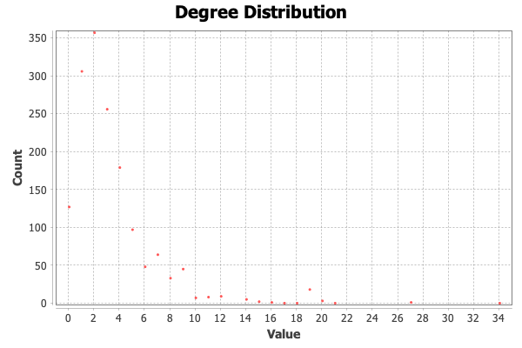

Figure 1.

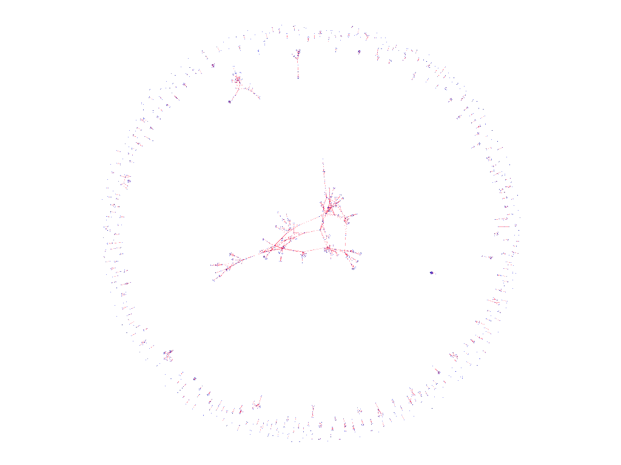

Figure 2.

The network is a scale-free network. Figure 2 shows network visualization in YifanHu layout. The degree distribution statistics shown in Figure 1 demonstrates that there are many nodes in the network with low degrees, while nodes with higher degrees are fewer in number. This is similar to the degree distribution of a scale-free network, which follows the power law function P(k) ~ $k^{γ}$.

The degree distribution of this network is not in normal distribution form. Also, the degree distribution of this network is not in Small-world network distribution form (skewness).

Actually, this network is a mixed model because of the presence of both disconnected nodes and small-world characteristics. However, the choice of network structure is based on the degree distribution that closely matches the degree distribution of netscience.

**2. ใครเป็นผู้ที่มีความสำคัญในเน็ตเวิร์คนี้ 3 อันดับแรก**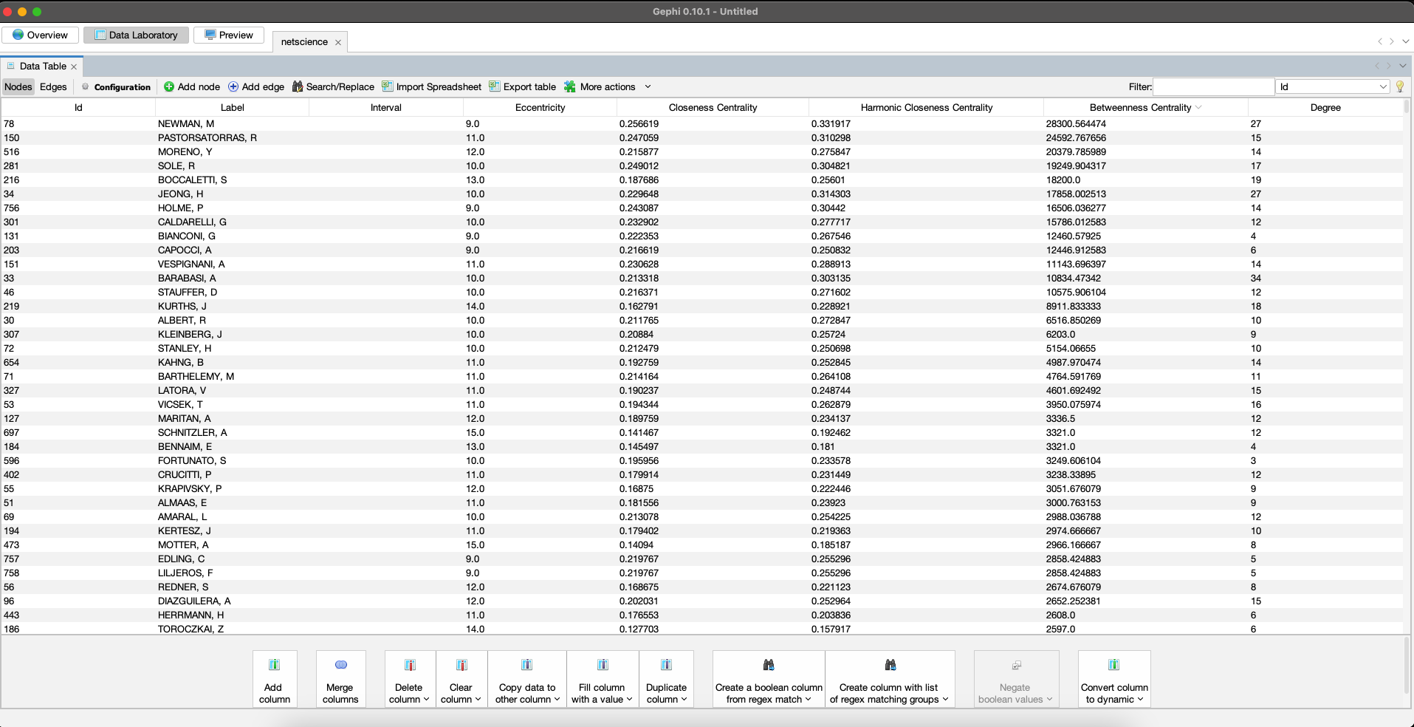

I determine the importance of each node using betweenness centrality, because this scale-free network has many nodes that serve as important pathways in the shortest path of each node. After computing the betweenness centrality, the top 3 most important nodes are

1. NEWMAN, M

2. PASTORSATORRAS, R

3. MORENO, Y.

Degree centrality could also be used to determine node importance, but I think betweenness centrality is more appropriate.

I didn't use closeness centrality in this case because the actual network contains many connected components or disconnected nodes that cannot be reached by most nodes.

Additionally, I didn't use the eigenvector centrality because it has an assumption of equal weighting of neighbors, which eigenvector centrality assumes that all neighbors of a node contribute equally to its centrality. However, in this network, certain neighbors may be more important than others.